France Section

President's Picnic 2024
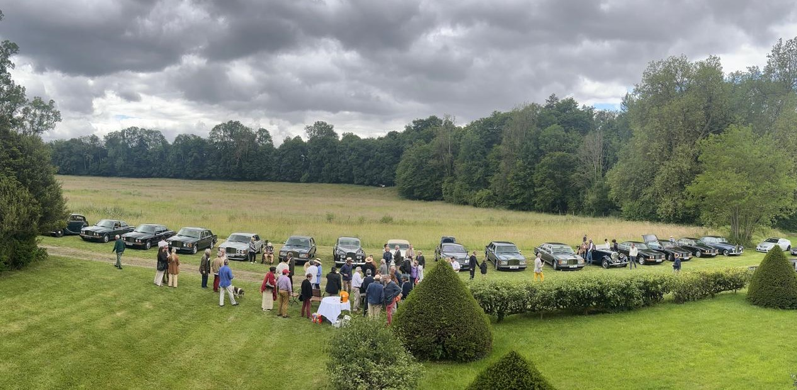
Thanks to our friend and dear former Chairman Pierre d'Allest, our traditional picnic was held on 18 June. And it was, once again, a success. Judge for yourself:
To begin with, the setting was just right for the event. We were welcomed at the château du Bignon-Mirabeau (https://www.chateaudubignonmirabeau.fr/): an original, vast and beautiful residence rebuilt in the 1880s by Ernest Samson, one of the greatest architects of the time, in the midst of magnificent parkland that we thoroughly enjoyed. But let me not forget the most important thing: the lovely welcome we received from the d'Aboville family, who own the property. This was appreciated by all the participants, without exception.
While we're on the subject of participants: twenty cars were present, seven Rolls-Royces and thirteen Bentleys. Parity, that's for another time... The oldest cars were the Bentley Mk VI (1949) owned by our President, and above all this magnificent Bentley 3.5-litre cabriolet from 1935, which we know well and which was a well-deserved success. The most recent car was a beautiful Bentley Continental GT coupé, as new.
What about the weather? Would you believe that in this dreary spring, it didn't rain at all! We even enjoyed some fine sunshine, particularly during the aperitif.
As in previous years, the Marek S. Milik Cup was awarded at the picnic. For those unfamiliar with its history, the cup was created in 1992 by our French section, following an initiative by Hunt House, the parent RREC, in 1991. The trophy honours the memory of Marek Milik, a member of the club who died accidentally in January 1991. Marek was (and I quote Dana, his widow) "a man of great generosity, with a great presence and a very British sense of humour. His talent as a graphic designer and his great professionalism were particularly evident in the creation and publication of the newsletters of the French section of the RREC".
The trophy is awarded every year to a member of the club who has made a particular contribution to the French section and its influence: it is both an act of remembrance and recognition of a deserving member.
This year it was awarded, in the presence of Dana, to Jean-Charles Hazet: a true amateur: passionate, enlightened and particularly generous.
The picnic ended in the afternoon with a visit to the gardens (designed by Achille Duchêne, a great landscape gardener of the late 19th century and the Belle Epoque, and recently restored) and the château, with its collection of chromolithographs.

Pascal de LA MORINERIE
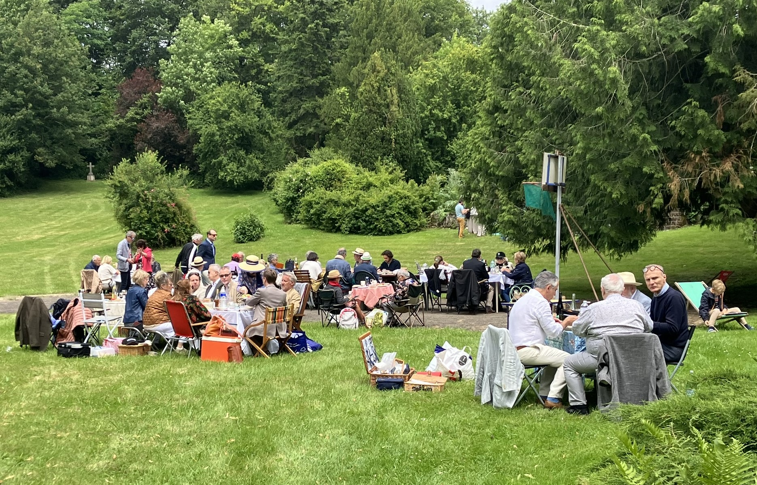

The picnic
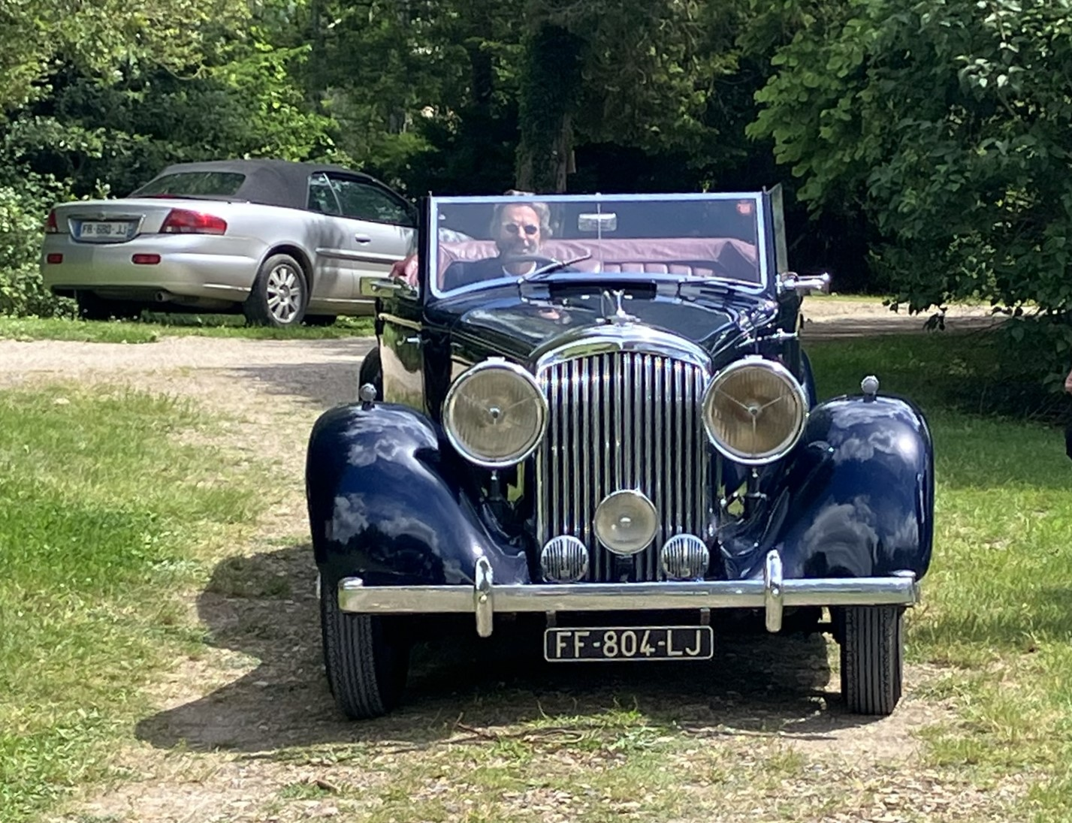
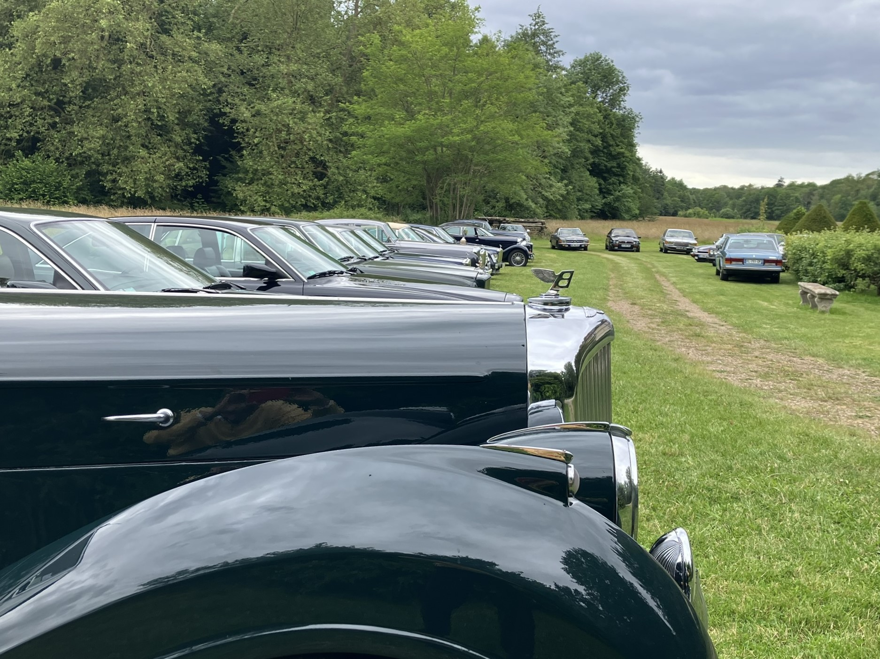

Twenty beautiful cars

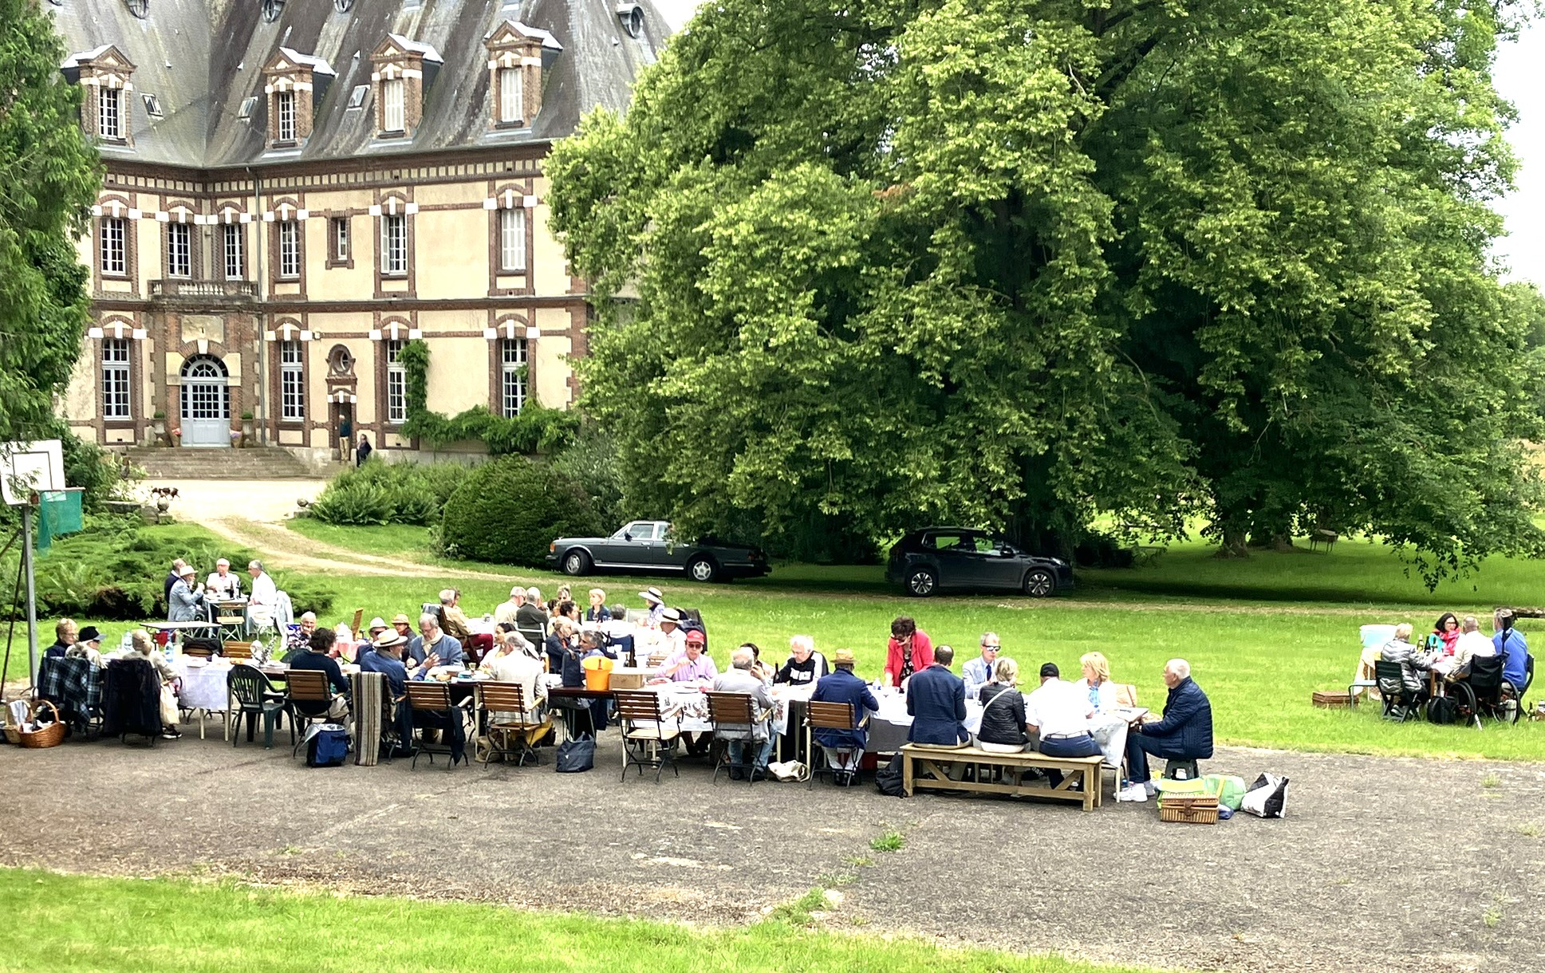
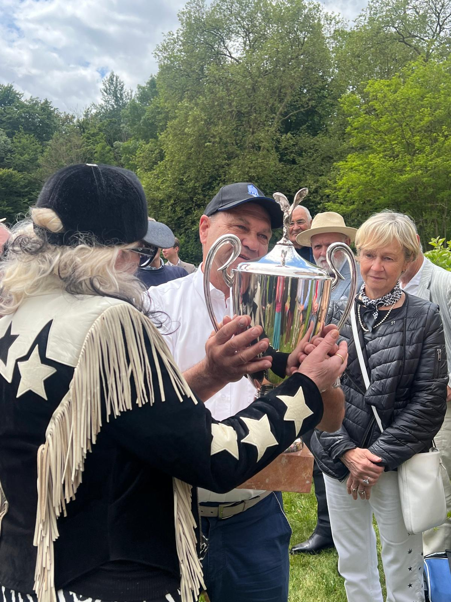

jj

The picnic again
Dana presents the cup to Jean-Charles and his wife Frédérique

